**Acropolis Institute Of Technology And Research,**

**Indore (M.P.)**



**Subject – Database Management System (DBMS)**

**(CY-405)**

**Name – Hariom Patidar**

**Enrollment No. - 0827CY221021**

**Branch - CS(Cyber Security)**

**Semester - 4th  (2nd year)**

**Submitted To – Mrs. Nidhi Nigam Ma’am**

**Index**

|  |  |  |  |  |
| --- | --- | --- | --- | --- |
| **Sr. No.** | **Experiment** | **Date of Exp.** | **Date of sub.** | **Grade** |
| 1. | To study DBMS and RDBMS, its characteristic comparisons and study of popular DB software. | 11/03/24 | 18/03/24 |  |
| **2.** | To study of Mysql ,features of my sql and installation of mysql. | 01/04/24 | 08/04/24 |  |
|  |  |  |  |  |
|  |  |  |  |  |
|  |  |  |  |  |
|  |  |  |  |  |
|  |  |  |  |  |
|  |  |  |  |  |
|  |  |  |  |  |
|  |  |  |  |  |
|  |  |  |  |  |
|  |  |  |  |  |

# **LAB WORK 2**

**INTRODUCTION OF MYSQL ,FEATURES OF MY SQL AND INSTALLATION OF MY SQL**

## **What is MySQL?**

**MySQL** is an**open-source, Relational Database Management System** that stores data in a structured format using **rows** and **columns**. It’s software that enables users to **create, manage**, and manipulate databases. Developed by **MySQL AB**, which is now owned by **Oracle** Corporation, MySQL is renowned for its reliability, scalability, and ease of use.

**FEATURES OF MYSQL**

Here are some key features and aspects of MySQL:

1. **Open Source:** MySQL is [open-source](https://www.geeksforgeeks.org/introduction-to-open-source-and-its-benefits/) software, which means it’s **free to use** and has a large community of developers contributing to its improvement.
2. **Relational:** MySQL follows the relational database model, allowing users to organize data into **tables** with **rows** and **columns**, facilitating efficient **data storage** and retrieval.
3. **Reliability:** MySQL has been around for a long time and is known for its **stability** and **reliability**.
4. **Performance:** MySQL is optimized for performance, making it capable of handling **high-volume transactions** and large datasets efficiently.
5. **Scalability:** MySQL can scale both **vertically** and **horizontally** to accommodate growing data and user loads. You can add more resources to a single server or distribute the workload across multiple servers using techniques like [sharding](https://www.geeksforgeeks.org/what-is-sharding/) or [replication](https://www.geeksforgeeks.org/data-replication-in-dbms/).
6. **Compatibility:** MySQL is widely supported by many **programming languages**, [frameworks](https://www.geeksforgeeks.org/what-is-a-framework/), and tools. It offers connectors and [APIs](https://www.geeksforgeeks.org/what-is-an-api/) for popular languages like PHP, [Python](https://www.geeksforgeeks.org/python-programming-language/), Java, and more, making it easy to integrate with your existing software stack.
7. **Security:** MySQL provides robust **security features** to protect your data, including access controls, encryption, and auditing capabilities. With proper configuration, you can ensure that only authorized users have access to sensitive information.

## **Applications of MySQL**

MySQL has used in various applications across a wide range of industries and domains, because of to its versatility, reliability, and performance. Here are some common applications of MySQL:

1. **E-commerce:**MySQL is extensively used in e-commerce platforms for managing **product catalogs**, **customer data**, orders, and transactions.
2. **Content Management Systems (CMS):** Many popular CMS platforms rely on MySQL as their backend database to store **website content**, **user profiles**, comments, and configuration settings.
3. **Financial Services:** MySQL is employed in **financial applications**, including banking systems, payment processing platforms, and accounting software, to **manage transactional data**, customer accounts, and financial records.
4. **Healthcare:** MySQL is used in **healthcare applications** for storing and managing **patient records**, medical histories, treatment plans, and diagnostic information.
5. **Social Media:** MySQL powers the backend databases of many social media platforms, including **user profiles**, posts, comments, likes, and connections.

# **InstallingMySǪLonWindows**

Inthistutorial, weareinstallingthelatestversionofMySQL(8.0.34)on

Windows11.Followthe givenstepstodoso−

**Step 1:** Firstly, choose the MySQL version and operating system. Then, wedownloadthedesiredMSIinstalleronyoursystembyclickingthe'Download'buttonshown in theimagebelow.This installerissuitableforboth32-bitand64-bitsystems.

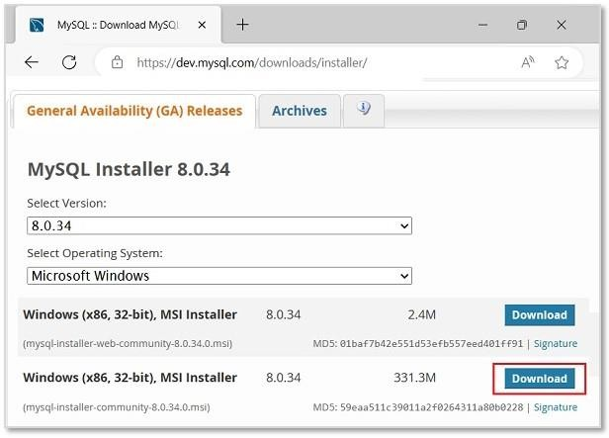

**Step2:** Then, we will be redirected to another file download page. Here,ignorethepromptsaskingtologinorsignupanddirectlystartdownloadingbyclicking onthelinkas shownintheimage.

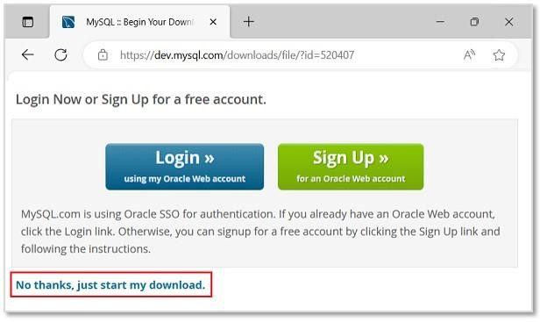

**Step3:**Oncetheinstallerisdownloaded,runittostarttheMySQLinstallation.

**Step 4:** Now, we can see the installer community window, asking tochoose a Setup type for our MySQL products. Choose **Custom** and click**Next**todecidewhatproducts we want toinstall.

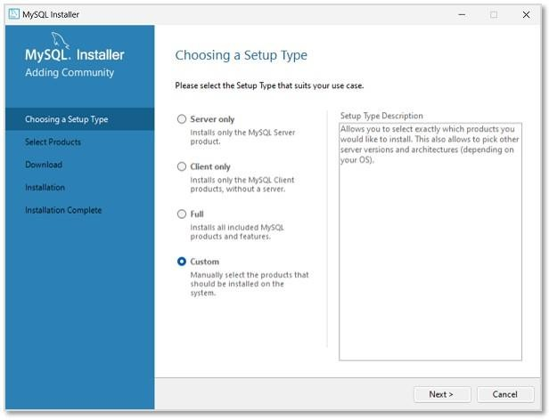

**Step 5:** In the next step, select MySQL Server, MySQL Workbench, MySQLShell (all latest versions) to be installed. We can also choose more productsavailable as pernecessity.

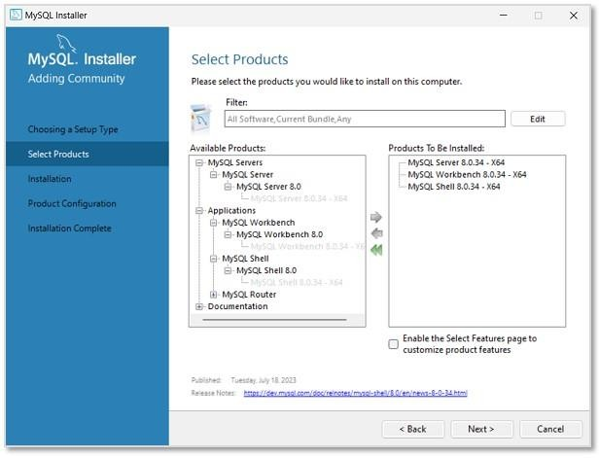

**Step 6:** The installation process will now begin. However, path conflictsmightariseifthereexistsapathdirectorywiththesamename.After theinstallationisdone

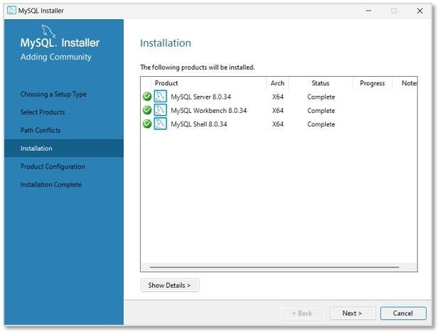

**Step7:**Inthisstep, wewillbeaskedtosetTypeandNetworkingofMySQL.Unlessthereisanyparticularchangewewanttomake, itis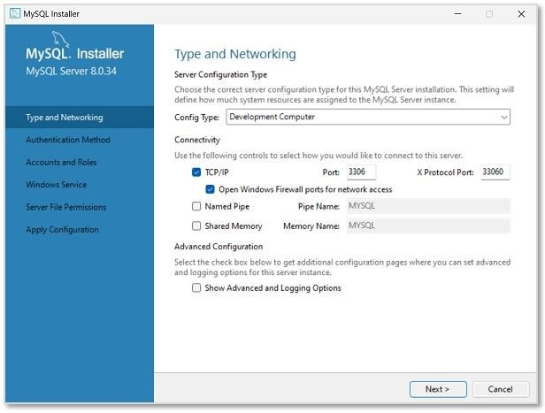recommendedtokeepthesettingsastheyare.

**Step 8:** Then, we need to set the Authentication method to access MySQLrootuser.So, choose the strongpasswordencryptionmethod.

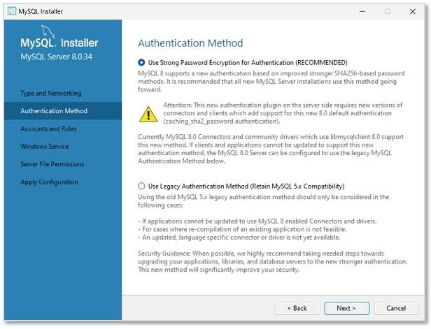

**Step 9:** Set a password for the root account. This password must alwaysbeusedtologintotherootaccountineverysession.After settingpassword

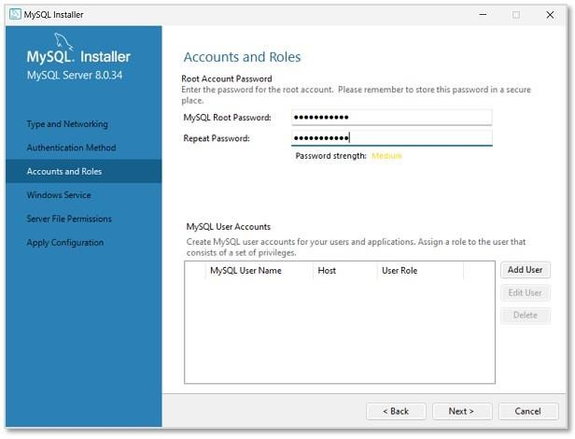

**Step 10:** In this step, MySQL Server Instance will be configured as aWindowsService.Thedefaultnamewillbesetas"MySQL80", whichcanbechangedifneeded

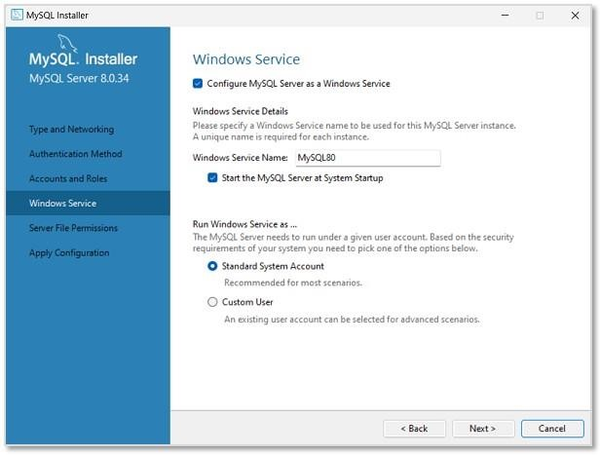

**tep11:**Now, setthefilepermissionsasrequiredandclick**Next**.

**Step 12:** As shown in the image below, the specified configuration stepswillbeapplied onclicking**Execute**.

**Step 13:** The installation is now complete. Uncheck the options asking tostartMySQLWorkbenchandShellafter setup,sothattheywillnotrunaftersetup.Click**Finish**.

